

|  |
| --- |
| **One of the easiest ways to visually estimate portion sizes is to use an everyday item that you carry around with you all the time, your hand.** |

**1** **ounce** of **cheese** is about the size of your **thumb**

A **teaspoon** of **margarine** is about the size of your **thumb tip**

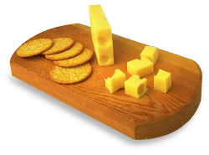

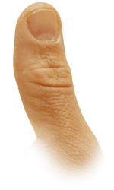

**1 cup** of milk, yogurt or chopped fresh greens is about the size of a **small hand** holding a **tennis ball**

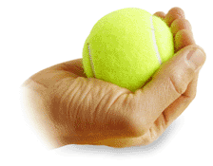

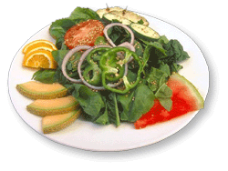

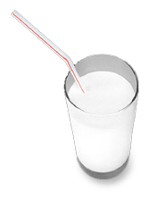

**1 oz nuts** or **small candies:**  
About **one handful**

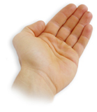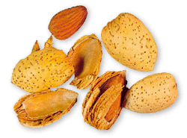

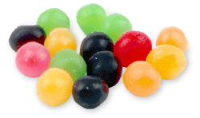

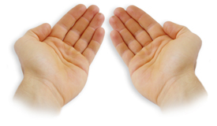**2 oz chips** or **pretzels:**  
About **two handfuls**

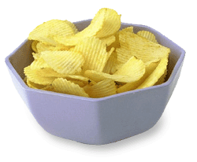

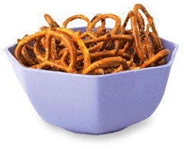

**1 cup:** About the size of a **man's fist**

[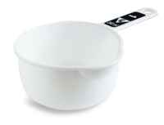](http://education.wichita.edu/caduceus/examples/servings/serving%20game%20pages/sta_one_cupl.htm)

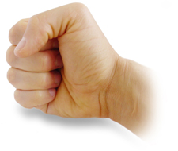

A **½ cup** of cut fruit, cooked vegetables, pasta, rice is about the size of a **rounded handful**

**3 ounces** of meat, poultry, or fish are about the size of a **women's palm**

**1/2 cup** of cut fruit, vegetables, or pasta is about the size of a **small fist**

**One ounce** of snack foods--pretzels, etc. equals a **large handful**



|  |
| --- |
| **Because hand sizes vary according to body, size, gender, and age, it may be easier to estimate portion sizes using some common household items.** |

|  |  |
| --- | --- |
|  | |
| **One piece fruit or potato:** About the size of a regular (60 watt) **light bulb  One-half cup** of vegetables is the size of a **light bulb** | http://education.wichita.edu/caduceus/examples/servings/images/light-bulb-275h.gif |
| http://education.wichita.edu/caduceus/examples/servings/images/red-apple-150w.gifhttp://education.wichita.edu/caduceus/examples/servings/images/pear-150w.gifhttp://education.wichita.edu/caduceus/examples/servings/images/potato-175w1.gif | |
|  | |
| **1/2 cup:** About the size of a **racquet ball** | |
| http://education.wichita.edu/caduceus/examples/servings/images/raquestball_170w.gif | http://education.wichita.edu/caduceus/examples/servings/images/half-cup-measure_250w.gif |
|  | |
| **One cup of pasta** is the size of a **tennis ball  3/4 cup:** About the size of a **tennis ball  1 fruit serving** = **½ cup canned** or **1 medium fruit** is about the size of a **tennis ball** | http://education.wichita.edu/caduceus/examples/servings/images/tennis-ball_175w.gif |
| http://education.wichita.edu/caduceus/examples/servings/images/bowl-of-fruit-salad-3_175h.gif | http://education.wichita.edu/caduceus/examples/servings/images/bowl-of-spaghetti-with-sauc.gif |
|  | |
| **1 1/2 - 2 oz cheese:** About the size of a **3.5" computer disk** or a **tube of lipstick** or **three dominos** | |
| |  |  | | --- | --- | | http://education.wichita.edu/caduceus/examples/servings/images/domino1_125w.gif | http://education.wichita.edu/caduceus/examples/servings/images/domino2_125w.gif | | http://education.wichita.edu/caduceus/examples/servings/images/domino3_125w.gif | | | http://education.wichita.edu/caduceus/examples/servings/images/computer_disk_150w.jpghttp://education.wichita.edu/caduceus/examples/servings/images/lipstick_175h.gif |
| http://education.wichita.edu/caduceus/examples/servings/images/cheese-and-crackers-2_250w.gif | http://education.wichita.edu/caduceus/examples/servings/images/Swiss-cheese_225w.gif |
|  | |
| **3 oz. meat/poultry/fish:** About the size of a **deck of cards** or **cassette tape** | |
| http://education.wichita.edu/caduceus/examples/servings/images/cassette-tape_175w.jpg | http://education.wichita.edu/caduceus/examples/servings/images/deck-of-cards_225w.gif |
| |  |  |  |  | | --- | --- | --- | --- | | http://education.wichita.edu/caduceus/examples/servings/images/toy-fish_150w.gif | http://education.wichita.edu/caduceus/examples/servings/images/cow-toy-150w.gif | http://education.wichita.edu/caduceus/examples/servings/images/artificial-rooster-and-chic.gif | http://education.wichita.edu/caduceus/examples/servings/images/pig-toy-150w.gif | | |
|  | |
| **2 TB peanut butter:** About the size of a **golf ball** | |
| http://education.wichita.edu/caduceus/examples/servings/images/bagel-with-peanut-butter-27.gif | http://education.wichita.edu/caduceus/examples/servings/images/golf-ball-150w.gif |
|  | |
| **One bagel** is the size of a **hockey puck** | |
| http://education.wichita.edu/caduceus/examples/servings/images/bagel_175w.gif | http://education.wichita.edu/caduceus/examples/servings/images/hockey%20puck_175w.jpg |
|  | |
| A **medium potato** should be the size of a **computer mouse** | |
| http://education.wichita.edu/caduceus/examples/servings/images/mouse_250w.jpg | http://education.wichita.edu/caduceus/examples/servings/images/potato-275w.gif |
|  | |
| **One teaspoon** of **peanut butter** equals **one dice**. | http://education.wichita.edu/caduceus/examples/servings/images/dice-alone_100w.gif |
|  | |

<http://education.wichita.edu/caduceus/examples/servings/table_of_contents.htm>

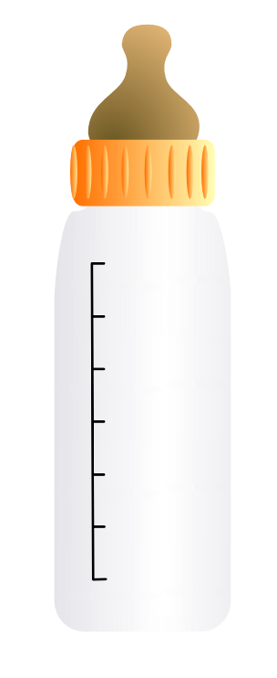

Baby bottles have marks on the side telling you how many ounces of liquid are in the bottle.